Disc Brake Conversion Instructions

Below are step-by-step installation instructions for our kit.
All pictures were taken using an axle that has been removed from the vehicle for clarity.
SAFETY FIRST
This job should be done on a solid flat surface using a quality jack and jack stands.
Set the emergency brake and chock the rear wheels before jacking the vehicle up.

Step 1:
After securing and jacking the vehicle up remove both front tires/wheels from the vehicle.
Step 2:
You will remove the bearing dust cap, remove the cotter pin and retainer, remove the axle nut, washer and outer bearing, remove the hub and drum assembly and set it to the side
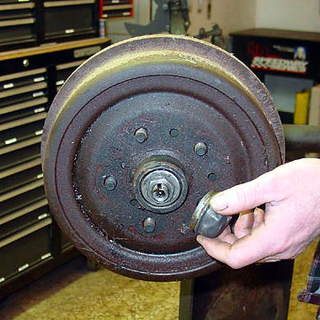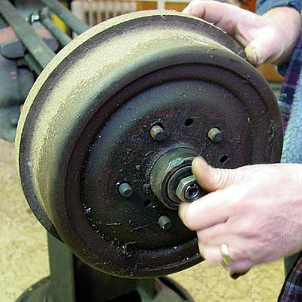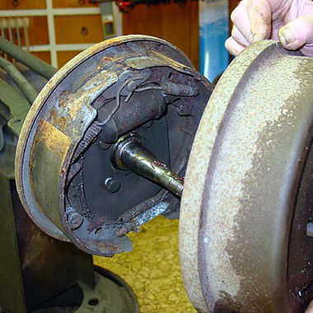

Step 3:
Clamp off the brake hose and unscrew it from the wheel cylinder, remove the 4 nuts and bolts holding the backing plate to the axle, 2nd pic. Remove the backing plate from the axle.
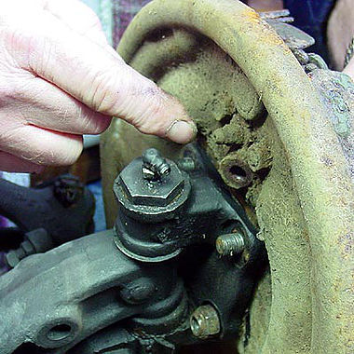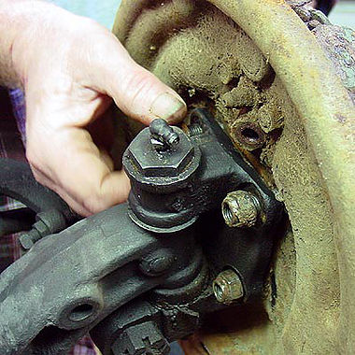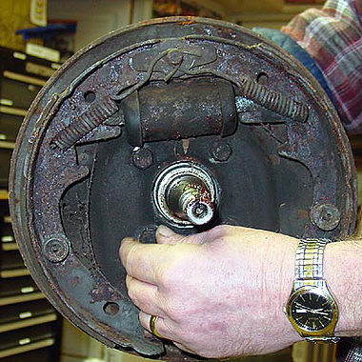

Step 4: Clean the mounting surface on the axle of all the debris and rust.

Step 5:
Next we need to separate the drum and hub assembly. The wheel studs are pressed through the hub and drum then swaged into place. Simply pressing them out will more than likely cause damage to the hub. The proper way is to cut the swaged material away from the drum and then press the stud out. If you do not have access to a swage cutter you can cut the exposed portion of the stud off with a cutoff wheel or similar device, at that point use a die grinder or disc grinder to grind away the swaged portion of the stud. Any decent machine shop should be able to do this for you as well.
Step 6:
After the studs are out you need to clean the wheel surface of the hub of all rust and debris. Before After
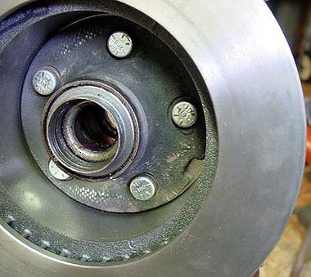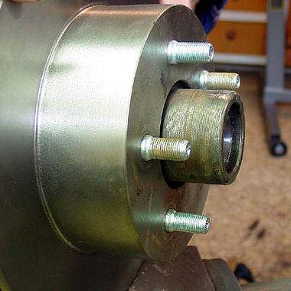
At this point it would be good time to remove the old wheel seal and clean out all of the old grease. Now to install the rotor and new wheel studs. We used a press for this. Set the rotor with the hat side down and then set the hub in with the wheel face down, Line up the wheel stud holes and drop in the studs, they will press into the hub and rotor with just a bit of the shank exposed on the wheel side. Pic 1. Pic 2.

Step 7:
Next we install the caliper bracket, it mounts with 1 bolt and 2 nut/bolt assemblies. The bracket installs to the back side of the spindle with the caliper mounting to the FRONT of the vehicle, line it up and loosely install the nuts/bolts, using some red locktite on the single bolt (before applying the loctite ensure the bolt is clean of all grease/oil etc..)screw it in and the tighten all the nuts and bolts. Pic 1. Pic 2. 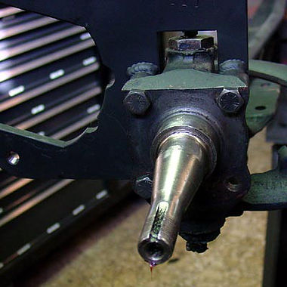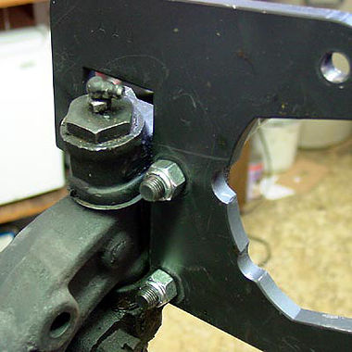
Step 8:
At this point you can repack your wheel bearings install new seals and reinstall them with the hub/rotor assembly. Please ensure the rotor braking surface and brake pad face are both clean, no grease or fingerprints. 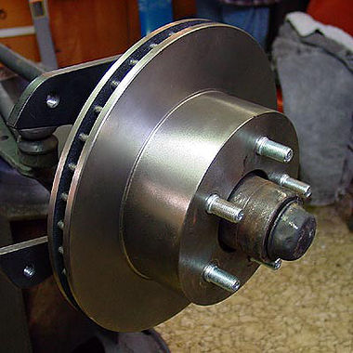
Step 9:
Before installing the caliper there are a couple of items that need attended to. First we need to lube the 4 o rings that the caliper slides on, lube them with the silicone brake lube. The outer brake pad has 4 points that should fit snug on the caliper, if they do not then you can bend the 2 smaller one until a snug fit is acheived. By doing this you cut down on any noise causing vibrations.

Step 10:
Install the caliper using the 2 supplied caliper slides/bolts, run them in by hand and then tighten with a allen wrench/socket. The caliper is to be mounted with the bleeder screw and hose mounting point to the top, ignore the L & R stamped in the caliper, this is not for our application.
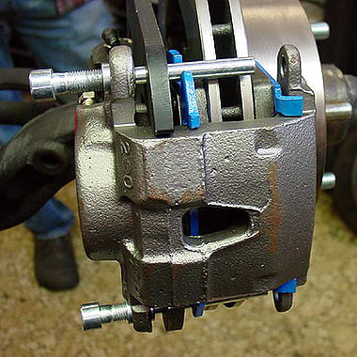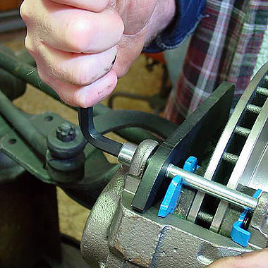
Step 11:
Get the new brake hose, banjo bolt and 2 hose washers. Put one washer on the banjo bolt, insert the banjo bolt through the hose, install the 2nd washer on the banjo bolt and then screw it into the caliper and tighten. Remove your original hose from the vehicle, enlarge the original hole in the hose mounting bracket so the new hose will fit through, use the supplied large nut to secure it in place. Screw the metal line into the new hose and tighten. 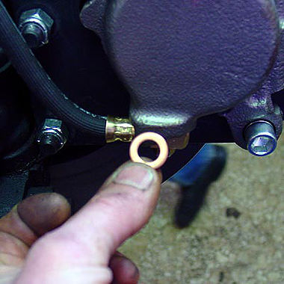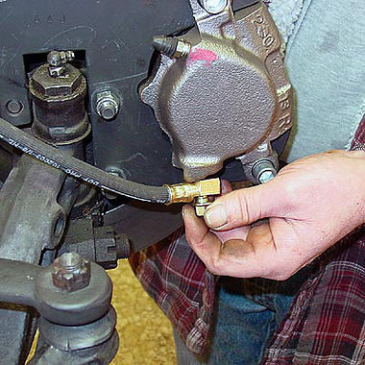
Step 12:
Bleed the calipers of all air, at this point top off the master cylinder and test the brake pedal, press firmly and check all hose connections for leaks. If it all looks and feels good then reinstall your wheels and lower the vehicle.

NOTE:
If using this kit with a stock master cylinder you will have to install an adjustable proportioning valve to achieve proper front to rear brake pressures. We recommend the ones from Wilwood or Jegs

Master Cylinder Conversion Instructions

This kit is a bolt on replacement for your original Econoline single or dual reservoir master
cylinder. If installing on a 1967 Econoline you will need a 1961-66 brake pedal and pushrod, the 67 is different and will cause problems if used with this application.
​
Please note that the brass pivot bushing in the bracket is a close tolerance fit, much more so than the stock plastic bushings used in the original Ford application. You may need to de-burr the outside edge of the pedal pivot with a file in order for the pedal to slide freely into the bushing.

There are 2 kits, one requires a remote reservoir which you must provide and are readily available through many different companies depending on the type and style you prefer. The other kit comes with a reservoir, clamps, hoses and adapters. I recommend mounting the remote fill inside the
doghouse for easy access and be sure to use brake fluid resistant hose with the remote reservoir. D&D Brakes will not be responsible for any damage that occurs if proper tubing or the correct pedal and pushrod are not used.
The original dust boot for the Econoline will fit on your new conversion. This kit will work on a drum/drum, disc/drum or 4 wheel disc application depending on the master cylinder bore used. If you have ordered the 15/16” bore cylinder (disc/drum) it comes with internal residual valves installed and no further plumbing is needed except for that included in the kit. The 1” bore (disc/disc or drum/drum) has NO internal residual valves installed and will require the use of inline residual valves available from Wilwood or jegs.com which you must acquire yourself. Drum brakes require 10 lb. residual while disc brakes require a 2 lb. Please be sure to install the correct residual for the application. The residual valves must be placed inline as close to the master cylinder as possible but safely out of the way.
​
The Primary or front disc outlet is the or smallest port on the master cylinder. Make certain to route your lines correctly. Some modification is required on the emergency brake bracket before installing with the master cylinder. You will need to remove a small amount of material from the rear of the bracket at the shaft end to avoid interference with the outlet line for the primary outlet. You will also need to notch the bracket for line clearance for the secondary outlet port. Neither of these modifications will affect the strength of the bracket itself. The pictures below show how I notched the bracket for my own use for the secondary port, once assembly has begun you will be able to determine how much material to remove for clearance for the primary port.

The line is a close fit with the emergency brake bracket so be sure you have enough material removed so there is no contact between the line and the bracket. Depending on the condition of your bracket, by that I mean possibly being bent over the years you may need to install a washer between it and the master cylinder bracket itself to gain proper clearance for the line. This will not affect the operation of the emergency brake nor its location in the vehicle, the hole in the floor is sufficient size for this small amount of movement. There may also be a need to notch the MC frame bracket in order for the ear on the new bracket to be installed. Some require this others do not, no real explanation but it has happened in the past.
​
The 8” line supplied with the 90 degree bend is the line for the rear port. This is supplied with the kit since it has the correct fitting and it is impossible to bend a standard steel line for clearance without collapsing it. This is also a good place to install a residual valve if needed for your application. The line will bend quite easily so you can position it where needed. Once everything is bolted up be sure your lines are all tight and thoroughly bleed the system. This is a totally new application and will require some time to be sure all the air is evacuated from the system. Check all lines and fittings again to insure there are no leaks. If you have the 15/16” bore master cylinder (disc/drum) you will notice a difference in pedal travel, this is normal and will just require getting used to it.
​
Also supplied with your kit is the new stop light switch which mounts directly to the brake pedal under the floor. Simply bolt the bracket to the pedal, adjust the switch so it contacts the floor when static and run two wires from the switch to your original brake light wires from your old switch.
​
REMOTE RESERVOIR & BRAKE LINE MODS
You will also have to purchase your own remote reservoir, hoses and fittings to the master cylinder adapters.
I would like to supply these with the kit but there are just to many options for remote reservoirs.
Your stock brake line configuration will need to be altered as well. You will need to have both rear brake
lines into a "T" and a single line coming from that to the master, both front brakes will also need the
same setup. You may need to purchase additional adapters or lines to get this done, I can't tell you
exactly what you will need unless I can physically look at your econoline. It may have been
changed/modified over the years from a stock configuration.
​
MAKE SURE TODOUBLE CHECK ALL NUTS, BOLTS AND LINE FITTINGS TO BE SURE THEY ARE TIGHT AND LEAK FREE!
Safety is the key here so lets be sure everything is correct before you hit the road. If you have any questions please contact us. D&D will not be responsible for any modifications to this application or any damage done or costs due to improper installation.
You will also have to purchase your own remote reservoir and hoses. I would like to supply these with the kit but there are just to many options for remote reservoirs. All in all this is the best upgrade to the Econoline yet. Late model parts, off the shelf and years of reliability, besides the safety factor of having a dual reservoir without having to spend big bucks on a 67 MC even if you can find one.

Sway Bar Adapter Instructions
If you use the Sway Bar Adaptor Brackets the installation is very easy. The long ½” bolt takes the
place of the original shock/sway bar bolt. Simply remove the original bolt from your axle and
replace it with the adaptor. Insert the long ½”bolt through the axle from the front, allowing the
tab to rest in the cove in the axle. This will place the open ½” hole above the axle itself.
Position and tighten the shock, this will lock the bracket in place. Insert a Grade 8, ½”x 2 1/2 bolt through the hole above the axle and sway bar endlink and tighten securely. This will position the bottom of the sway bar endlink directly ABOVE the axle not in front.
This is extremely important so that you have proper caliper clearance at full turn.
​

